**PACKAGES REATED TO DS**

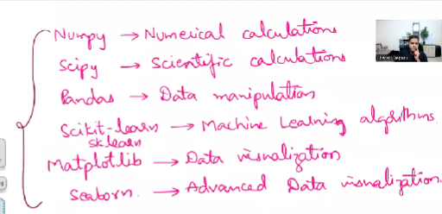

We will get error when we install these libraries like this package is not capable for this version of OS or python, instead of installing these libraries will we install anaconda software which will correct this errors automatically when we try to install it.